# Inductor Design

The determined inductance of the buck converter is 120 µH, so that both CCM operation and ripple condition is met. In this part magnetic design of the inductor and core selection will be explained.

First the cable that will be used to wind the core is selected. The average current of a buck converter inductor is the output current. Since the battery will be charged with 10A the inductor current will also be 10 A. Thus, high voltage cables that can endure more than 10A are investigated. H07V-K1.5 which can carry up to 16 A is selected. The copper area of the cable is 1.5 mm2. Also, the average outer diameter of the cable with insulation is 2.9 mm. The area of this cable can be calculated from:

$$A_{cable}=π{\left(\frac{D}{2}\right)}^{2}=6.6 {mm}^{2}$$

Then permeability vs DC bias curves of the Kool Mµ cores that are available in the laboratory are obtained from Magnetics [1]. The permeability fit formulas from [1] are given in Figure 1 and the permeability vs DC magnetizing field (Oe) is given in Figure 2.

Figure 1 Kool M Toroid Permeability Fit Formula

Figure 2 Permeability vs DC Magnetizing Field Curve

From this fit formula and physical properties of the magnetic core AL, which is inverse of the reluctance, is written as a function of the MMF which is turns number times the current. MMF and AL can be written in terms of relative permeability and magnetizing field as follows:

$$A_{L}=\frac{1}{R}=\frac{μ_{0}μ_{r}A }{l}$$

$$MMF=NI=H l$$

$$l=magnetic path length$$

$$A=cross sectional area of the core$$

$$A_{L}=\frac{μ_{0} μ_{r} A l}{100\left[a+b{\left(\frac{MMF}{l \frac{Oestred}{A/m}}\right)}^{c}\right]}$$

Since the inductor current is known which is 10 A the inductance can be computed from these parameters.

$$L=\frac{N^{2}}{R}=\frac{MMF A_{L} }{I^{2}}$$

The fixed point iteration method is applied to find the turns number (N) that will yield 120 µH inductance. The block diagram of the algorithm is given in Figure 3.

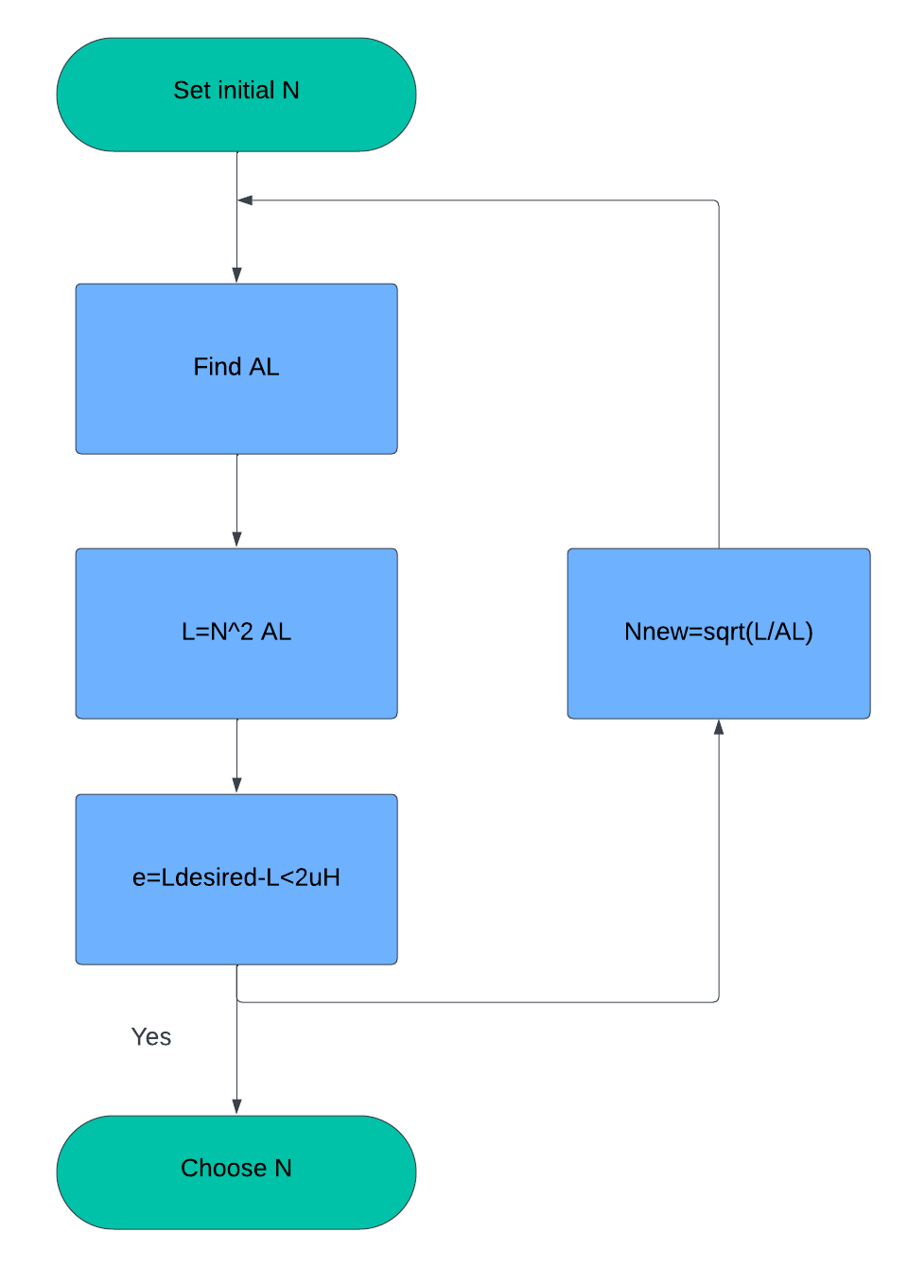

Figure 3 Fixed Point Iteration Block Diagram

According to the selected turns number and the window area of the core Awindow the fill factor is calculated as follows.

$$Fill Factor=\frac{N A_{cable}}{A_{window}}$$

More than 60% fill factor is not plausible. To be safe it is aimed that the fill factor will be kept lower than 50%.

According to these considerations 0079192A7 Kool Mµ core is selected. The typical DC Bias curve is given in Figure 4. The turns number is determined as 32 which gives AL 121.8 nH/T2.

The window area of the selected core is 514 mm2. Fill factor can be calculated as follows.

$$Fill Factor=\frac{{NA}_{cable}}{A_{window}}=0.411=41.1\%$$

As it can be seen that the fill factor is smaller than %50 hence it is possible to design this inductor. According to the datasheet, the winding length per turn for 40% fill factor is 77.8 mm. Hence, the total length of the cable must be approximately 2.5 m. The resistance of the selected cable is 13.3 mΩ/m. The expected resistance of the cable is 33.25 mΩ.

The measured resistance and the inductance from the LCR meter at switching frequency 50 kHz, are 111 mΩ and 142 mH respectively. Since the LCR meter applies a small voltage, the calculated inductance is without the saturation. Hence the expected result is given below.

$$L_{unsaturated}=N^{2}A_{L,max}=141.36 mH$$

It can be seen that measured inductance is very close to the calculated result. For saturation, a special test is applied to the inductor which will be explained in Test Results section.



Figure 4 Typical DC Bias Curve of 0079192A7